1. Write a simple program in any language you want that outputs "I'm on

%HOSTNAME%" (HOSTNAME should be the actual host name on which the app

is running) and deploy it to Github

-- Using python

import os

myhost = os.uname()[1]

print('Iam on {}'.format(myhost))

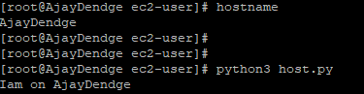

2. Write a Dockerfile which will run your app

→ vi index.htnl

This is my application

:wq

Vi dockerfile

---------------------------------------------------------------------------

FROM centos

RUN yum install httpd -y

COPY index.html /var/www/html/

CMD [“/usr/sbin/httpd”,” -D”,” FOREGROUND”]

EXPOSE 80

----------------------------------------------------------------------------------

3. Create Github Actions Pipeline to Build the Docker image and push to

AWS ECR

→

4. Extend the Actions Pipeline to deploy the app to AWS EKS

→

5. Setup KubeCtl on AWS EKS

→

1. curl -o kubectl<https://amazon-eks.s3.us-west-2.amazonaws.com/1.17.9/2020-08-04/bin/linux/amd64/kubectl>
2. openssl sha1 -sha256 kubectl
3. chmod +x ./kubectl
4. mkdir -p $HOME/bin && cp ./kubectl $HOME/bin/kubectl && export PATH=$PATH:$HOME/bin
5. kubectl version --short --client